

Lab Methods and Constructors

BY:

ABDULLAH

(FA22-BCT-004).

SUBMITTED TO:

MA’AM SANEEHA AMIR.



September 20, 2023

COMSATS UNIVERSITY

ISLAMABAD.

# **QUESTION#1:**

1. Create a class Account class with balance, yearofOpening and CNIC as data member. Create:
   1. Default constructor
   2. One-argument Constructor (balance)
   3. Three- argument constructor
   4. setValues()
   5. display()
   6. withDraw()
   7. deposit()
   8. calculateAgeOfAccount()

## **CODE:**

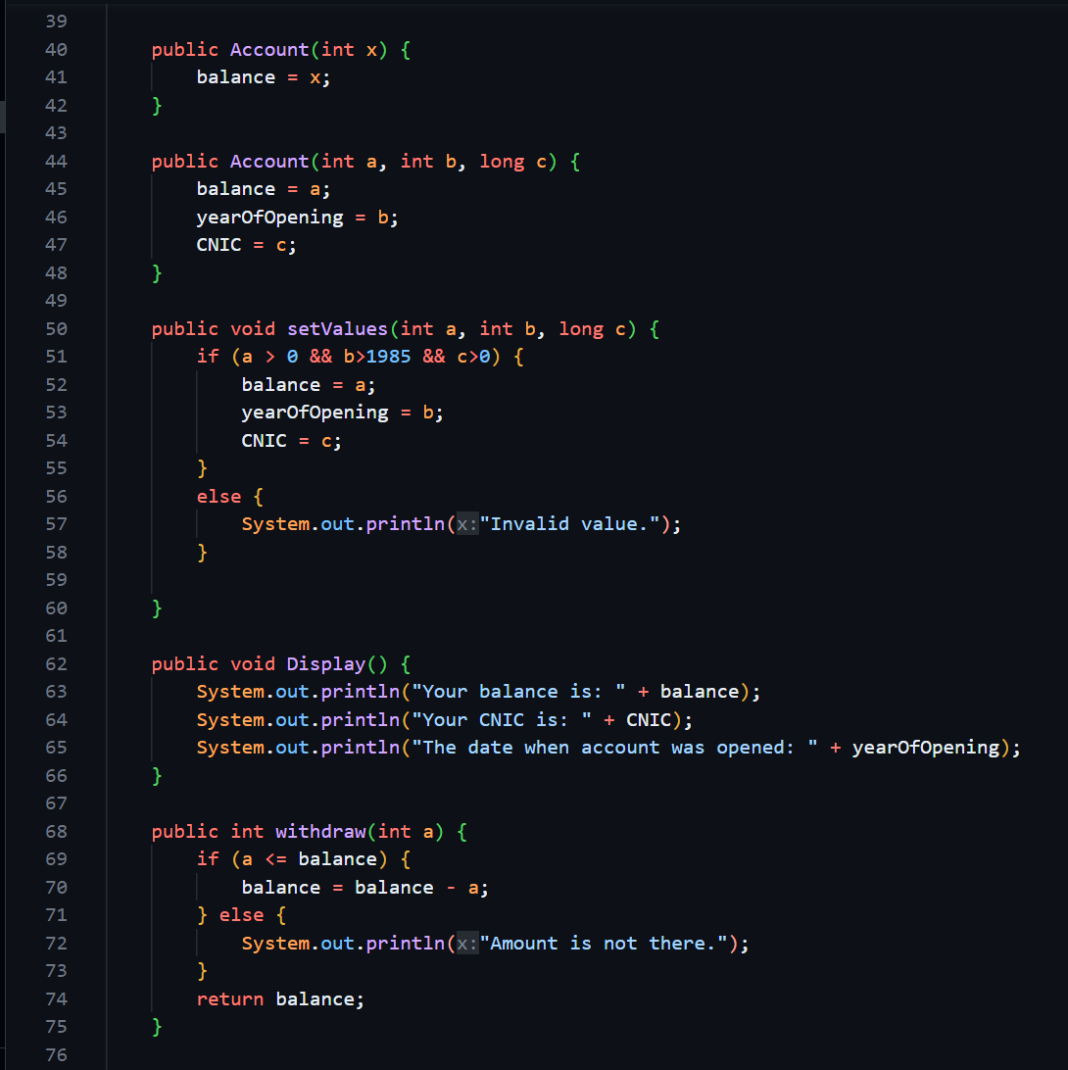

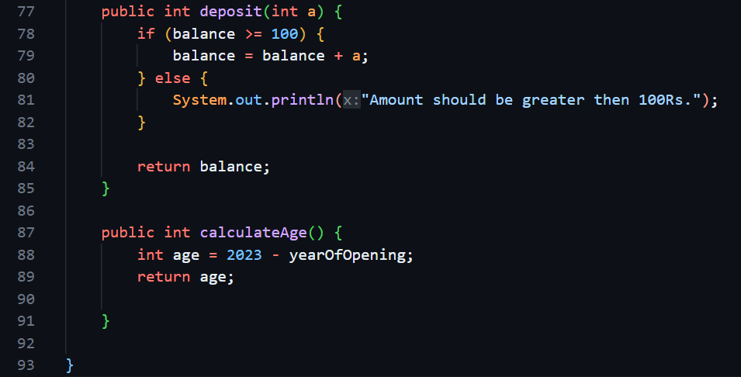

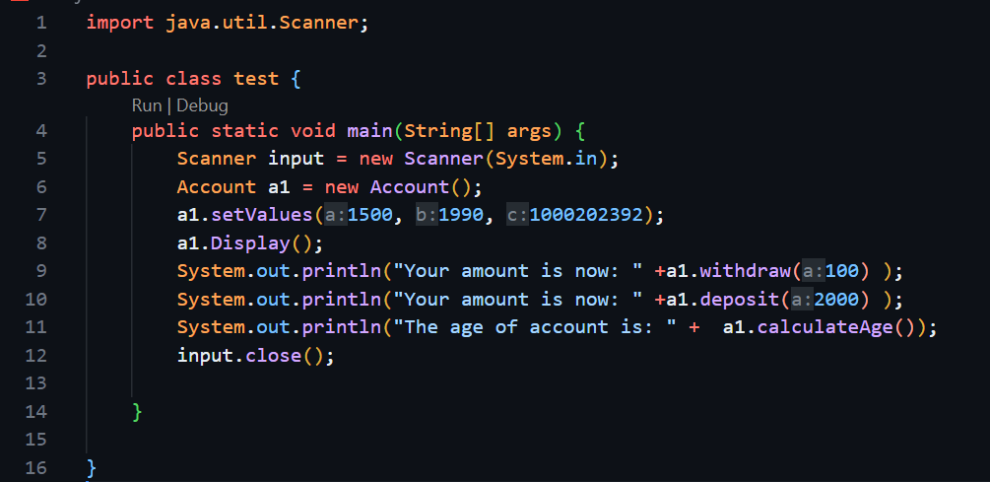

# **QUESTION#2:**

1. Create a quadratic Equation Class with **a, b and c** as data members. Create
2. Default constructor
3. Three- argument constructor
4. Display()
5. setValues ()
6. getDiscriminant() //returns double
7. checkIfDescriminantIsGretaerThan100() //Boolean return

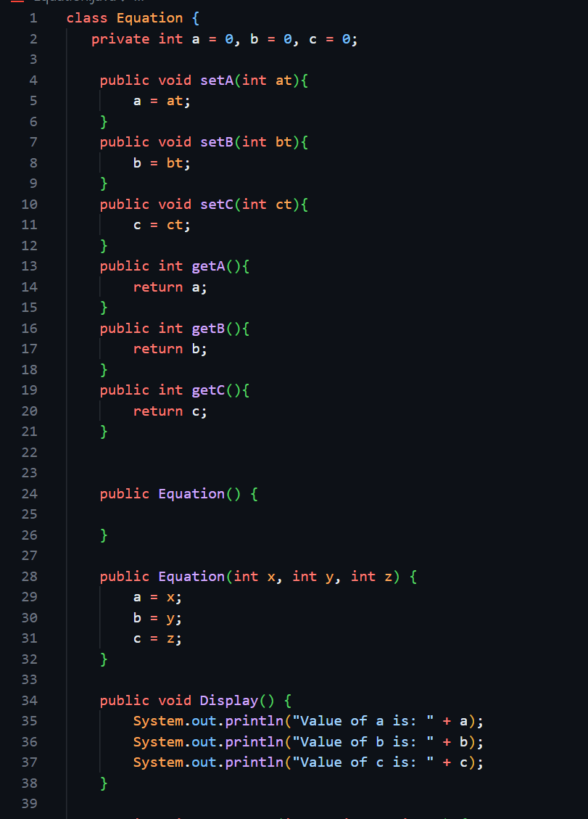

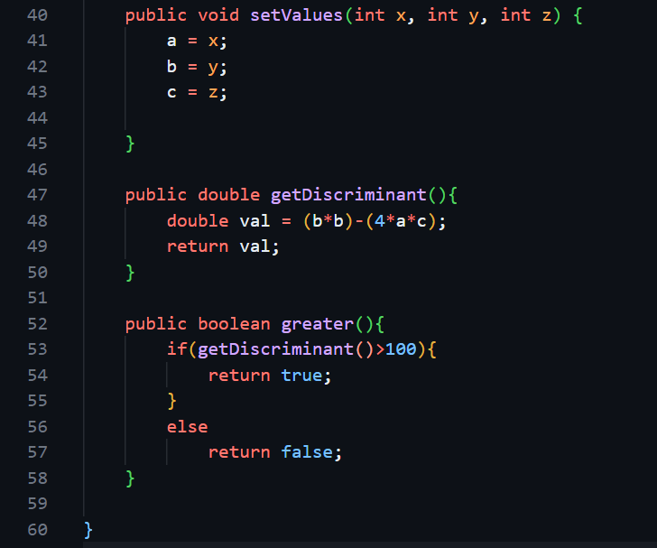

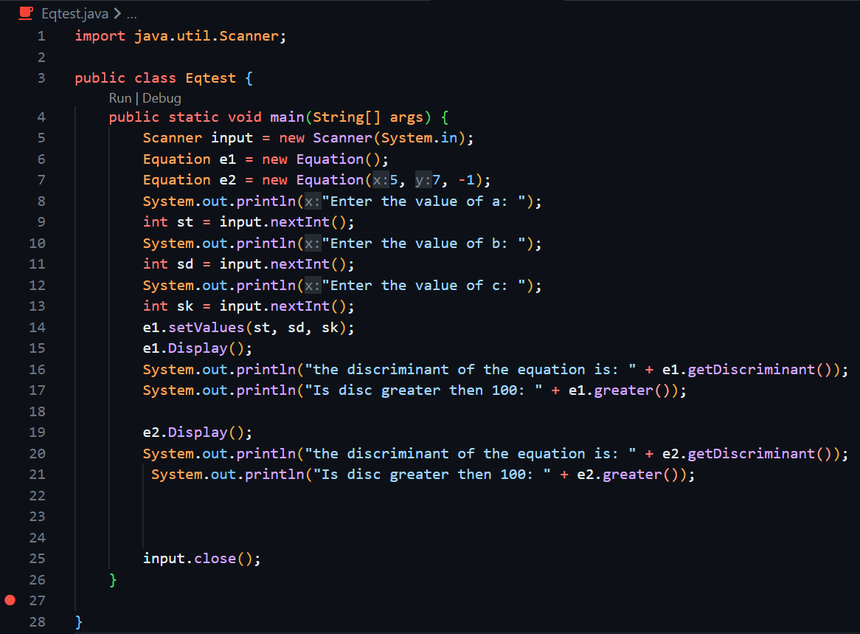

# **QUESTION#3:**

1. Create a class Rectangle with length and width as data members. Create
   1. Default constructor
   2. two- argument constructor
   3. Display()
   4. setValues ()
   5. calculateArea ()
   6. checkSquare () //Boolean return

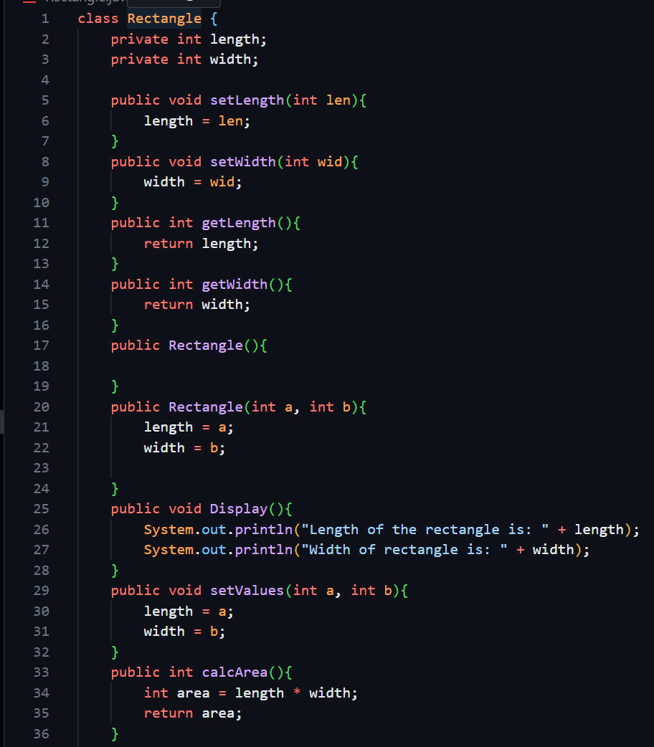

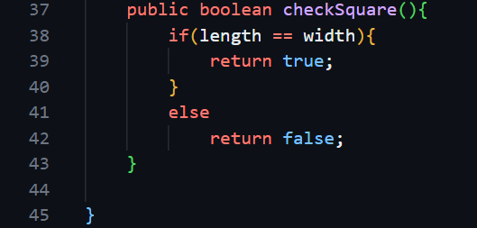

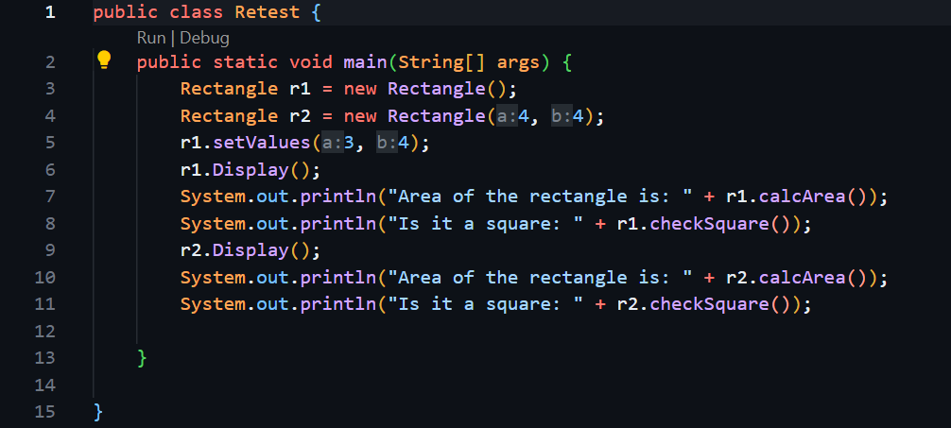

# **QUESTION#4:**

1. Create a class Point class with x and y as data members. Create
   1. Default constructor
   2. two- argument constructor
   3. Display()
   4. setValues ()
   5. move ()
   6. checkOrigin () //Boolean return

# 

# 

# 

# **QUESTION#5:**

1. Create a Book class with author and chapterNames[5] as data members. Create
   1. Default constructor
   2. two- argument constructor
   3. Display()
   4. setValues ()
   5. checkIfAuthorNameStartsWithA ()
   6. searchChapter () //Boolean return

# 

# 

# **QUESTIO#6:**

1. Create a Student Class with name, Gpa, subjects[5] and email as data members. Create
   1. Default constructor
   2. four- argument constructor
   3. Display()
   4. setValues ()
   5. searchSubject ()
   6. checkProbStatus () //Boolean return
   7. validateEmail() //Boolean return

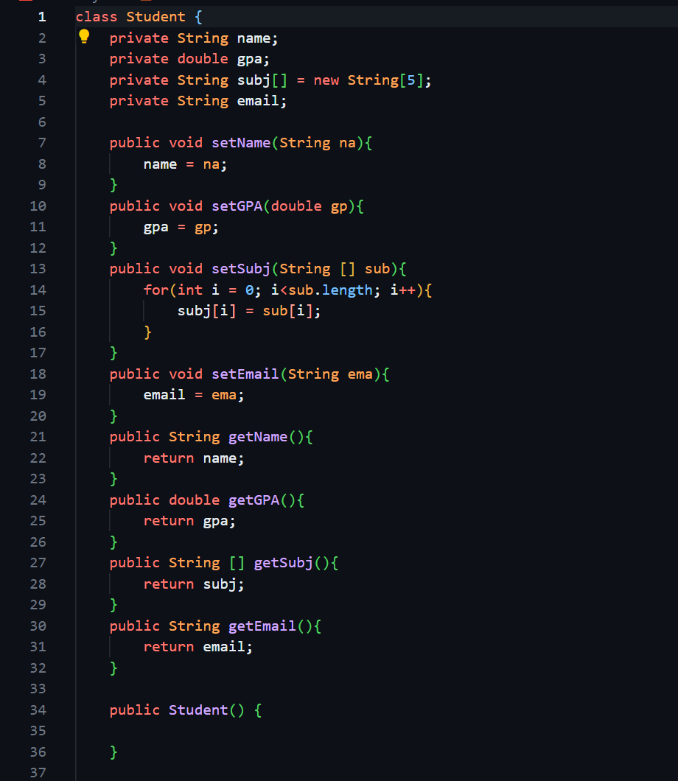

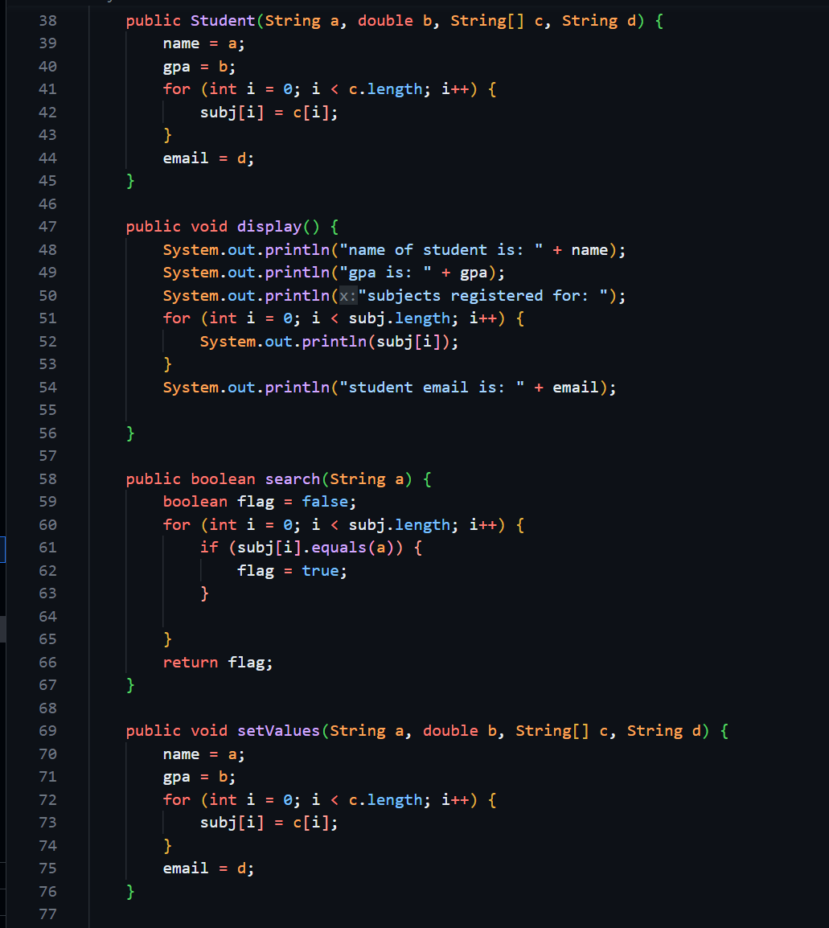

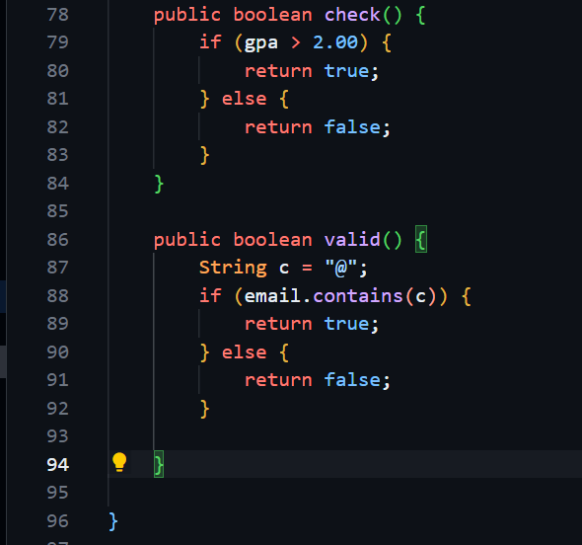

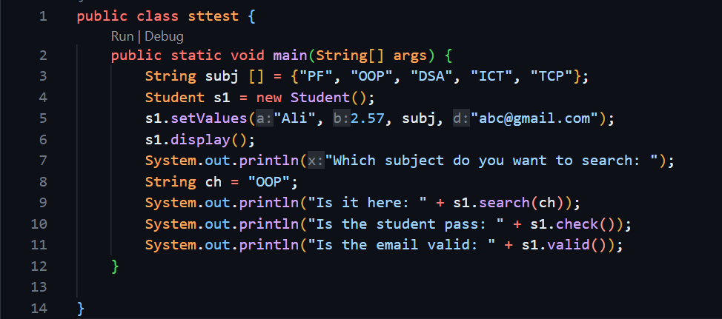

# **QUESTION#7:**

